Good descriptions of the products:
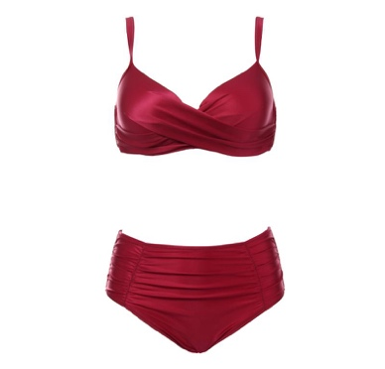
In category Underwear & Swimwear

Material: Spandex, Polyester
Lining Material: Cotton
Pattern: Solid
Bra Type:Push Up
Waistline: High Waist
Support Type: Underwire
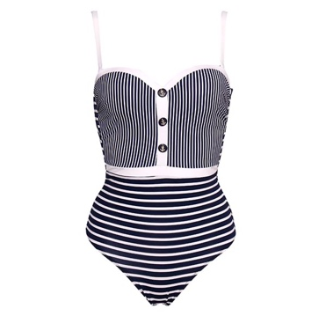

Material: 82% polyester, 18% Spandex
Pattern Type: Striped
Decoration: Buttons

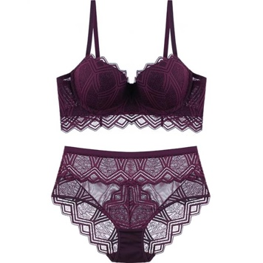

Material: Polyester
Closure Type: Back Closure
Pattern Type: Solid
Bra Style: Push Up
Decoration: Lace

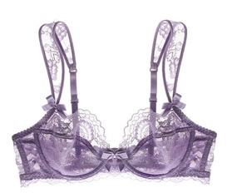

Material: 90% Spandex and 10% polyester
Decoration: Lace
Pattern Type: Solid

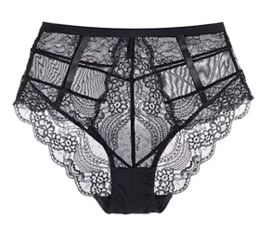

Material: 90% Spandex and 10% polyester
Decoration: Lace
Pattern Type: Solid
Waistline: High

