Good descriptions of the products:
In category Dresses
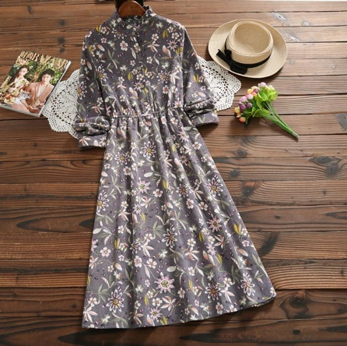
Material: Polyester, Cotton
Silhouette: A-Line
Sleeve Length: Full
Neckline: Ruffled
Style: Vintage
Length: Mid-Calf
Pattern Type: Floral
Decoration: Button

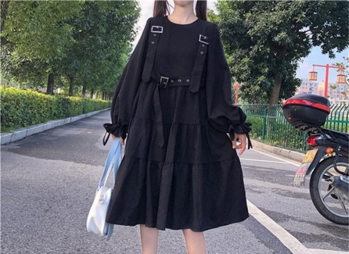

Material: Polyester
Neckline: O-Neck
Decoration: Ruffles
Style: Gothic
Silhouette: A-line

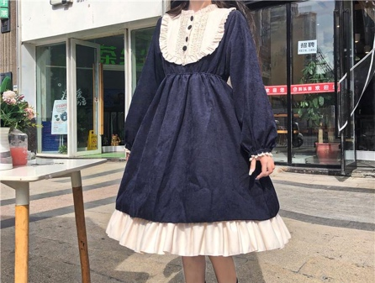
Material: Polyester, Lanon
Decoration: Ruffles
Waistline: High
Silhouette: Ball Gown
Pattern Type: Patchwork
Style: Lolita
Neckline: Ruffled

Material: Acrylic
Decoration: Knitted
Silhouette: Sheath
Length: Above Knee

