Good descriptions of the products:
In category Tops (t-shirts, blouses, shirts, cardigans, blazers, pullovers, sweaters, hoodies, bodies, vests)
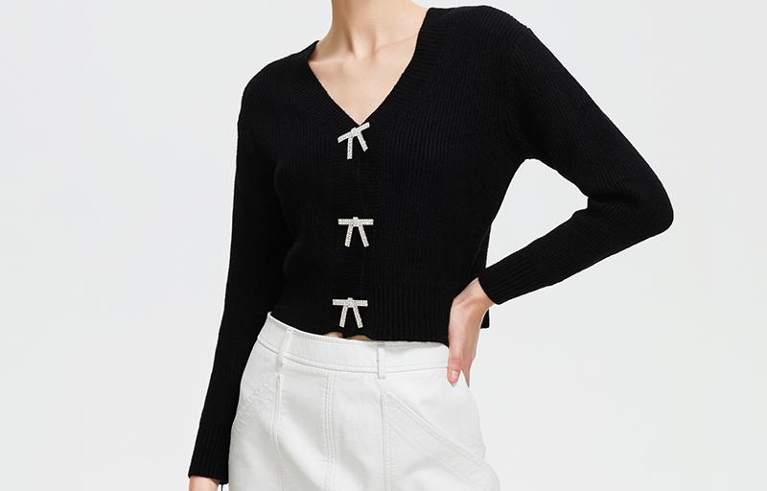
Material: 65%Polyester, 35%Cotton
Style: Casual
Clothing Length: Short
Sleeve Length: Full
Decoration: Button

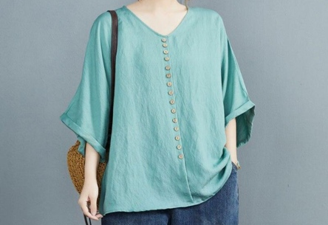

Material: Cotton, Linen
Decoration: Button
Sleeve Length: Short
Fit Type: Loose
Collar: V-Neck

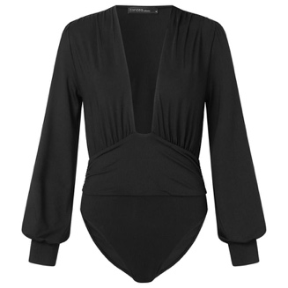
Material: 95% Polyester+5% Spandex
Sleeve Length: Full Sleeve
Neckline: V Neck
Pattern: Solid Color
Closure Type: Button

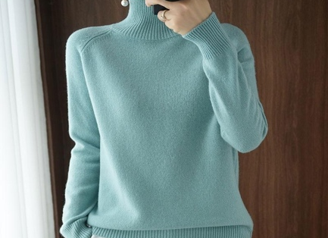
Material: Wool
Material: Acrylic
Neckline: Turtleneck
Pattern Type: Solid
Season: Autumn, Winter
Sleeve Length: Full

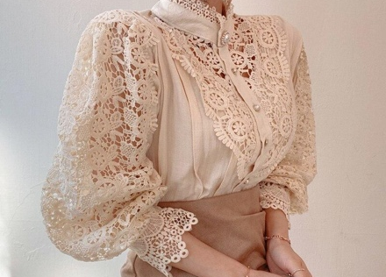

Material: Polyester
Decoration: Lace
Decoration: Pearl Button
Sleeve Length: Full
Sleeve Style: Petal Sleeve

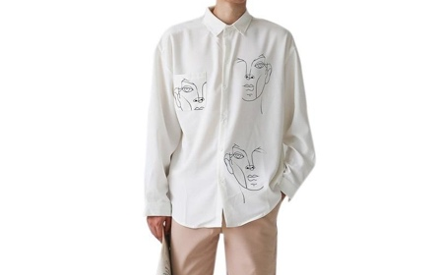
Material: Polyester
Length: Long
Sleeve Length: Full
Pattern Type: Print
Collar: Turn-down Collar
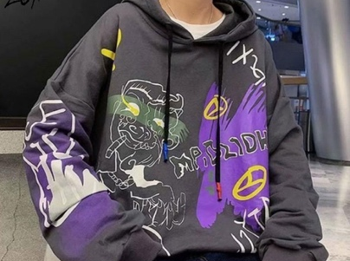
Material: Polyester, Cotton
Season: Winter
Sleeve Length: Full
Hooded: Yes
Pattern Type: Print

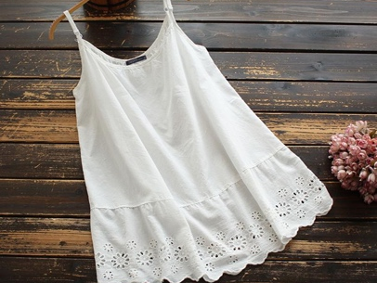

Material: 100% Cotton
Sleeve Length: Sleeveless
Neckline: O Neck
Pattern: Lace Patchwork

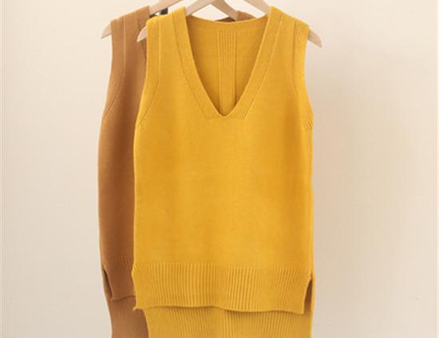

Material: Acrylic and Polyester
Decoration: None
Collar: V-Neck
Pattern Type: Solid

