Good descriptions of the products:
In category Outerwear (coats / parkas / trench)

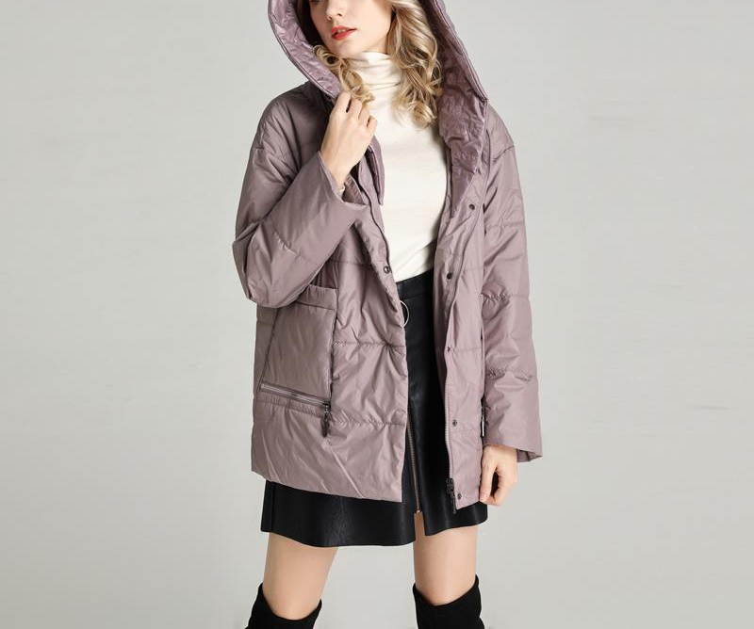
Material: 100% Polyester
Filler: 100% Polyester
Lining Material: 100% Polyester
Pattern Type: Solid
Decoration: Pockets,Zippers
Closure Type: Zipper
Sleeve Length: Full
Hood: Detachable
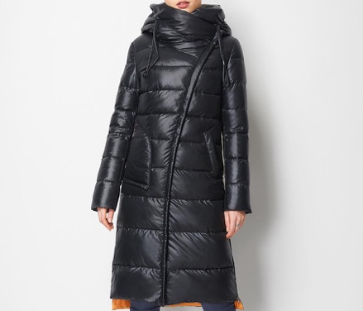

Material: Cotton
Lining Material: Polyester
Filler: Sustans
Weight: 1.35kg
Closure Type: Zipper
Sleeve Length: Long
Hooded: Yes
Decoration: Asymmetric Zipper
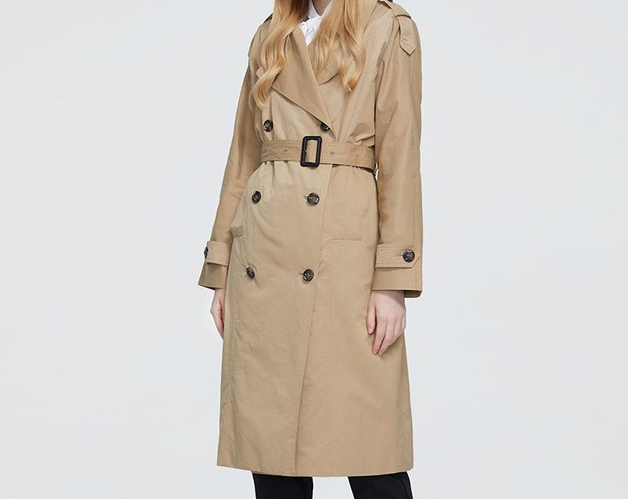
Pattern Type: Solid

Material: Polyester
Decoration: Pockets
Decoration: Belt
Closure Type: Double Breasted
Collar: Turn-down Collar

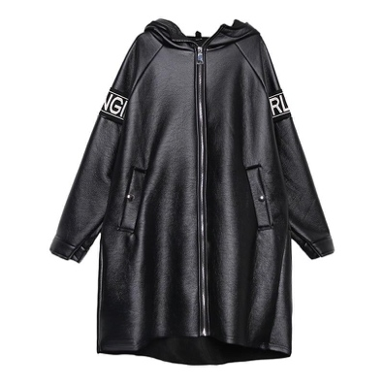

Closure Type: Zipper
Decoration: Pockets
Decoration: Spliced
Style: Streetwear
Sleeve Style: Regular
Sleeve Length: Full
Material: PU

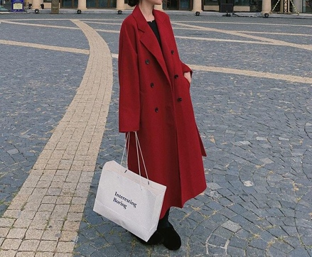
Material: Polyester
Season: Spring/Autumn
Collar: Turn-down Collar
Closure Type: Single Breasted
Sleeve Length: Full
Pattern Type: Solid
Decoration: Belt

