Good descriptions of the products:
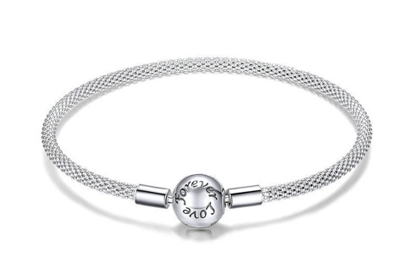
In category Jewelry & Bijouterie

Material: 925 Sterling Silver
Main Stone: Cubic Zirconia
Closure Type: Hidden-safety clasp
Chain Type: Snake Chain

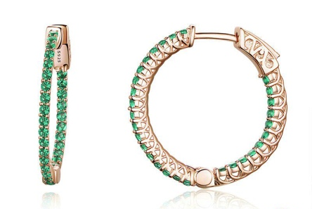

Material: Sterling Silver 925
Main Stone: Zircon
Size: 2.6*0.2cm
Weight: 4.7 g
Closure Type:

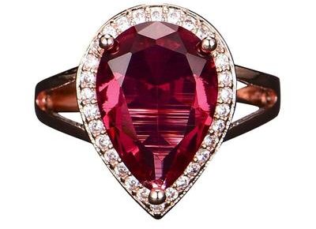

Ring Size: Adjustable
Material: Copper Alloy
Main Stone: Zircon

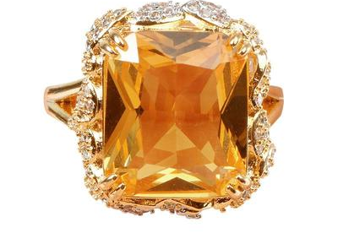
Material: Copper Alloy
Main Stone: Zircon
Stone Shape: Square
Sizes: US Size 6(Dia): 16.5mm/0.65"
US Size 7(Dia): 17.3mm/0.68"

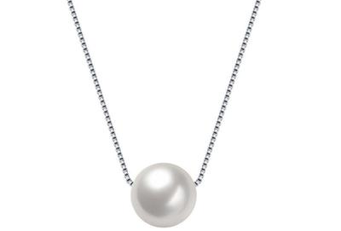

Material: 925 Silver
Main Stone: Faux Pearl
Necklace Length: 40cm/15.76"
Extension Length: 2cm/0.79"

