Good descriptions of the products:
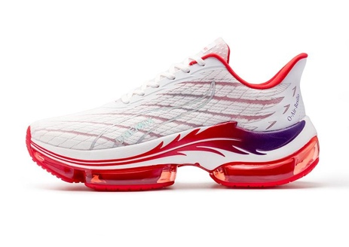
In category Footwear

Insole Material: PU
Upper Material: Mesh
Outsole Material: Rubber
Closure Type: Lace-Up
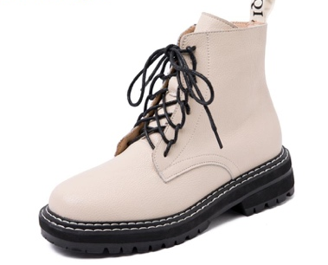

Upper Material: Cow Leather
Insole Material: PU
Outsole Material: Rubber
Lining material: Faux Fur

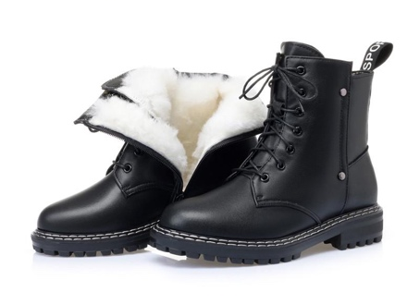
Upper Material: Cow Leather
Heel Type: Square heel
Lining Material: Natural wool
Shaft Material: PU
Toe Shape: Round
Insole Material: Plush
Outsole Material: Rubber

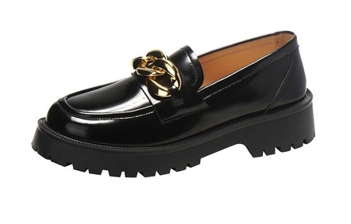
Heel Type: Square heel
Upper Material: Cow Leather
Toe Shape: Round
Heel Height: 3cm
Decoration: Metal Chain
Insole Material: PU
Lining Material: PU
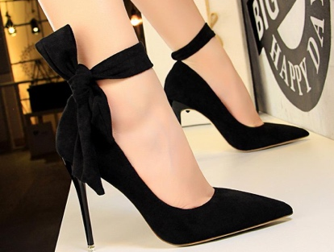
Outsole Material: Rubber

Upper material: Suede
Sole Material: Rubber
Inner material: Faux Leather
Heel height: High

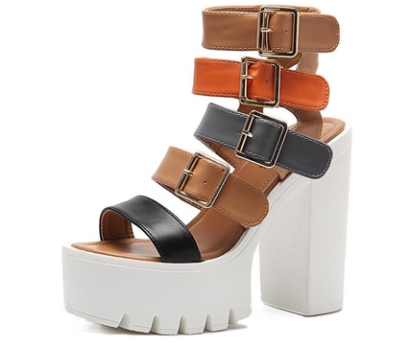
Upper Material: PU
Heel Height: 13 cm
Platform Height: 4.5 cm
Outsole Material: Rubber
Closure Type: Buckle Strap

