Good descriptions of the products:
In category Bottoms (trousers, shorts, skirts, leggings, jeans)
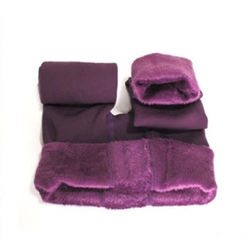
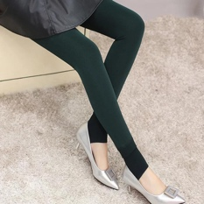
Material: Polyester, Spandex
Fit Type: Skinny
Thickness: Thick
Waist Type: High Waist

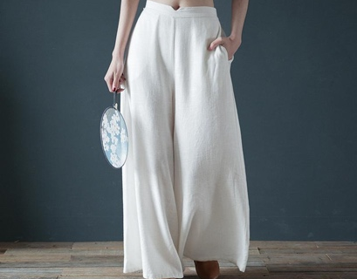

Material: 100% Cotton
Fit Type: Loose
Closure Type: Elastic Band
Waist Waistline: Middle
Decoration: Side Pockets

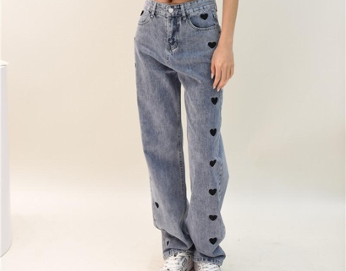
Material: 90% cotton, 10% polyester
Waist Type: High
Closure Type: Zipper
Decoration: Pockets
Fit Type: Loose

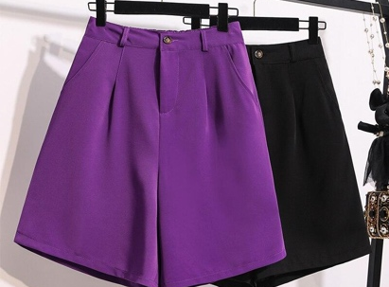
Material: Cotton+Polyester
Fit Type: Loose
Closure Type: Zipper
Closure Type: Button
Pattern Type: Solid

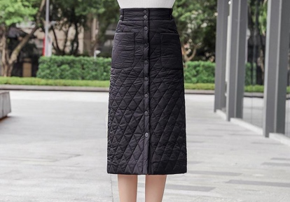

Material: Cotton, Polyester
Decoration: Pockets
Waistline: High
Length: Long

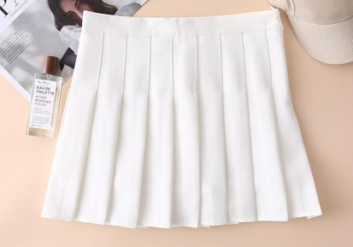
Material: Polyester
Decoration: Pleat
Waistline: Middle
Pattern Type: Plaid
Closure Type: Zipper
Feature: With Inner Shorts

